G4-Test Notice 考試通知 CH. name: ________
- 時間Time: __Oct._month __30_day , on __Mon.__ (weekday)
- 範圍 Content: 中秋節- tradition & activity & legend
- 題型 Format: Four sections
- Matching: Connect the key word to the relevant picture, and write the Chinese word under the picture
1-團圓飯 2-月亮 3-柚子帽 4-燈籠 5-月餅 6-烤肉

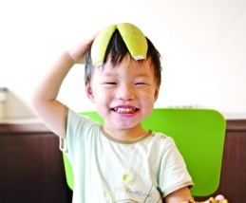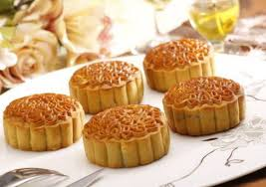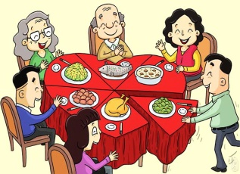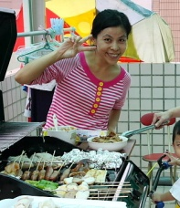
( ) ( ) ( ) ( ) ( ) ( )
- True or False: Read silently each statement and see if they are correct or not.
1.中秋節又叫做八月節----------- ( )
2.嫦娥最後飛到了太陽 ----------- ( )
3.東母娘娘給了后羿仙丹----------- ( )
4.十個太陽都是玉帝的兒子 ----------- ( )
5.后羿射下了九個太陽 ----------- ( )
- Multiple choices: Read each sentence and circle the right answer to match the content we have learned.
- 從前可怕的怪獸會出來吃(人/魚)。
- 大地又乾又熱，皇帝想用(后羿/嫦娥)來祭天。
- 嫦娥吃了(仙果/仙丹)以後就飛起來了。
- 嫦娥每年的(中國年/中秋節)能跟后羿
團圓。
- 最後后羿(有/沒有)回到天宮。
- Meaning comprehension: Translate CH. phrases and short sentences into appropriate English meaning.
- 天上有十個太陽____________________________
- 后羿有一位美麗的妻子。_________________________________
- 嫦娥真的飛了起來。______________________________________
- 太陽很頑皮，不聽后羿的話。______________________________________
- 日夜不停地想念在月宮的嫦娥。
______________________________________

- 老師的叮嚀Teacher’s reminder-
- Review 10 sentences for project and various activities for celebration and understand the meaning of it.
- Go through the key words on word practice sheets.
- Understand the legend of the moon story; study the worksheet of the story.
- It will be very helpful if your family gives you a pre-test at home.

